Setting up MailChimp and Abandonment
Summary of steps:
Generate the API key, deliver to MSG ecommerce staff for installation on the site
Create a list to attach to a campaign
Create a campaign, optional, attach to google analytics
Create an abandonment workflow

To get your apikey:

Find or Generate Your API Key

If you want to set up an integration with your MailChimp account, chances are high that you'll need to generate an API key. Users with Manager permissions can generate and view their own API keys. Users with Admin permissions can also see API keys for other account users. Below, you'll learn how to grab an existing API key or generate a new one.

- Click your profile name to expand the Account Panel, and choose Account.
- Click the Extras drop-down menu and choose API keys.
- Copy an existing API key or click the Create A Key button.
- Name your key descriptively, so you know what application uses that key.

Send your API key to the Ecommerce developers so we can put it in the website.

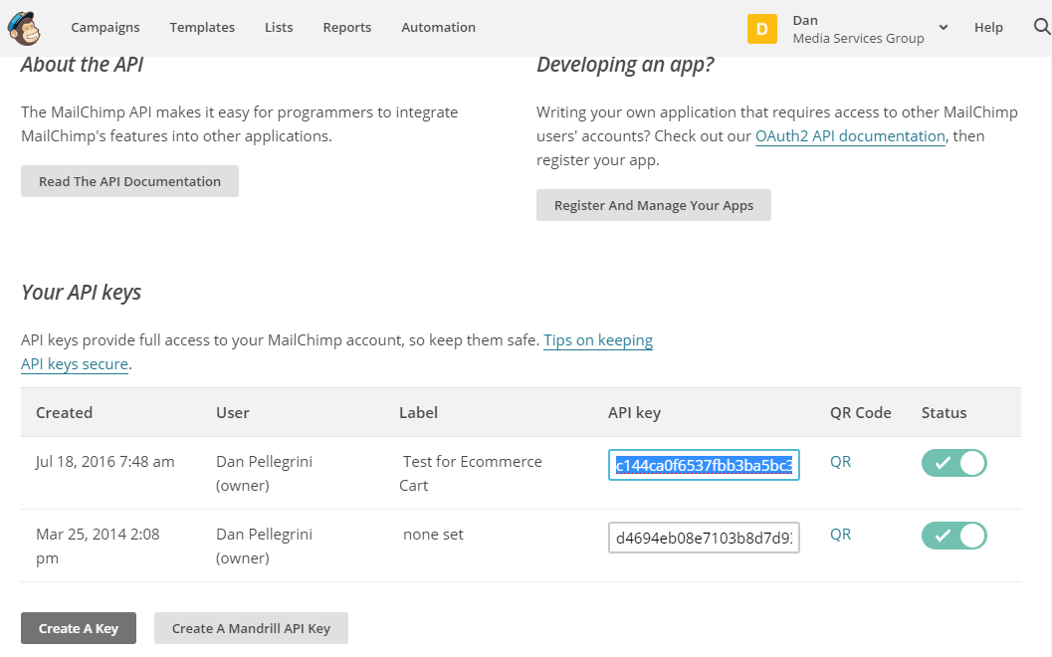

Once the MSG ecommerce people enter the api key, the msg ecommerce folks run the create store. It is located at:

YOURCARTURL/Utility/MailChimp

If the store has already been created, it will tell you.

Campaigns:

A campaing and a LIST for the campaign are used OUTBOUND, so you can send promotions to customers on the list

You can choose to send out promotions FROM this list/campaign FIRST to get people to go to the store. If you have tracking on, then mailchimp will write a cookie with the campaign codes in it which is passed back to mailchimp on a store order.

When campaign tracking is on - When tracking is turned on, mail chimp automatically add two tags to each URL in your campaign that tell the mailchimp when subscribers make a purchase from a certain campaign.

see mailchimp page:
http://kb.mailchimp.com/integrations/e-commerce/how-to-use-mailchimp-for-e-commerce?&_ga=1.227080984.4050428.1467921918

mc_cid is the internal MailChimp-generated ID for the specific campaign.

mc_eid is the unique, MailChimp-generated ID for each subscriber.

After your campaign is sent, mailchimp tracks these link tags and add them as a site cookie that passes purchase information back to MailChimp. The results appear in your MailChimp reports and in subscriber profiles.

See below for setting up a list and then attaching it to a campaign.

Abandonment Workflow

To do an automatic abandonment email, you have to add an "automation" or "workflow", the term seems to be used interchangeable

http://kb.mailchimp.com/automation/create-an-abandoned-cart-workflow

Create an abandonment cart workflow:

Here are some things to know before you begin this process.

This workflow is only available to paid users who have e-commerce data in their account from MailChimp for Shopify or custom API 3.0 integrations.

You’ll need to connect your store in your MailChimp account before you can create this Automation workflow. (in our case, run the store setup page in the shopping cart.)

You can only have one Abandoned Cart workflow per connected store. If you manage multiple stores, you can create one workflow for each.

You need to create a separate LIST for your cart abandonments. All users of the cart will go on the list as OPT IN (Its just the way it works), so you don’t want to co-mingle this with other existing lists.

There are three entities in MailChimp, a customer, a cart and and order. All customers who use the cart are going to end up on the list as active, regardless of if they converted or not. The customer is actually separate from the cart. When the CART is started (when a user places an item into the cart, a CART is made in mailchimp, AND a customer is added to the list . When a customer places the order, the CART is removed and an ORDER is inserted into mail chimp with the same contents (it's actually a duplicate of the cart). So turning on the automation should only work on carts, and there is no need to be concerned with the customer record.

You must include the Cart content block in your Abandoned Cart email. Classic templates are not currently compatible with the Abandoned Cart workflow.

If a customer in the Abandoned Cart email queue makes a purchase before the email is sent, they’ll automatically be removed from the queue.

Setting up the adminstrator for ecommerce:

You have to set up a campaign (which is basically the design of the email that you send out), which means you have to have a list for the campaign:

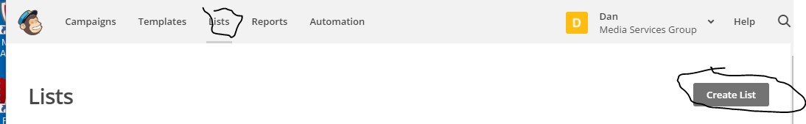

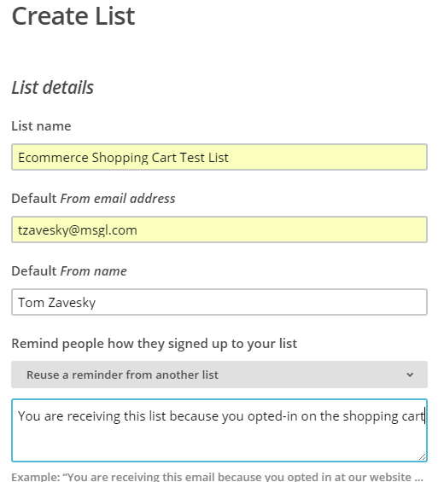

Create New List, then go to the LISTS menu at the top and select your list:
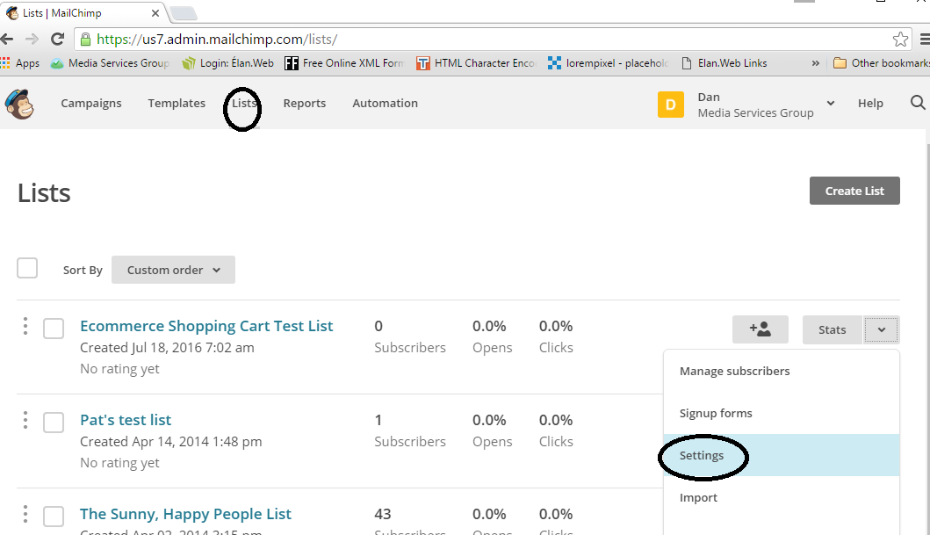

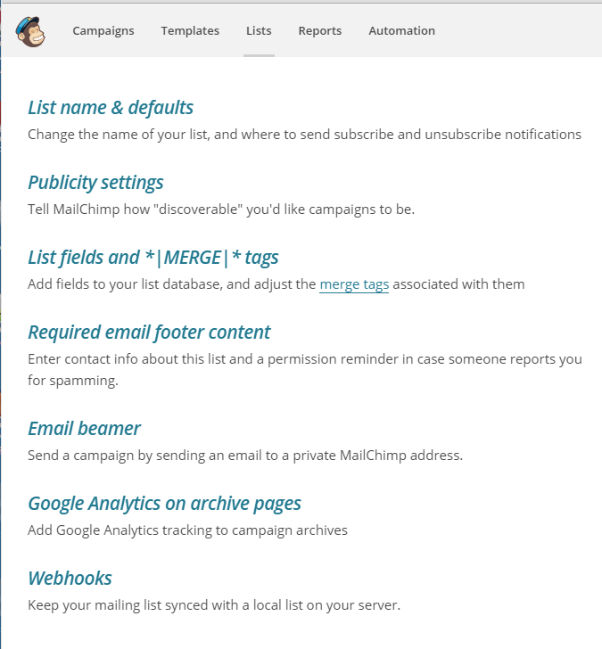

Send the list ID to the MSG Ecommerce developers for installation on your site. (see RED) on this screentshot for the list ID:

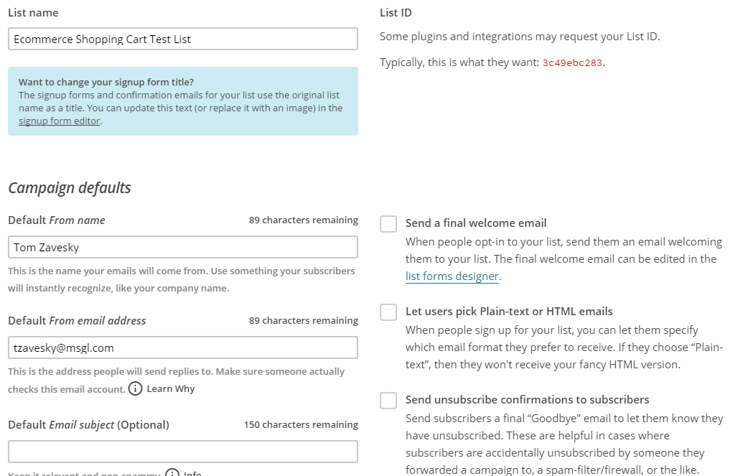

You may need to add fields for data here. By default, the list only includes the email address, firstname and lastname.
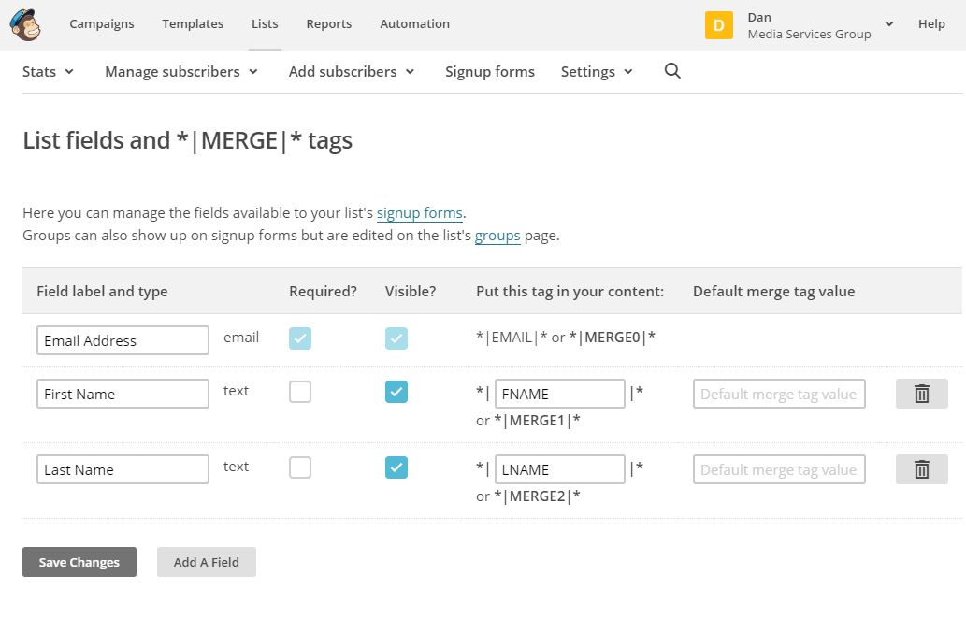
Next you have to create a campaign and your list goes on that campaign:

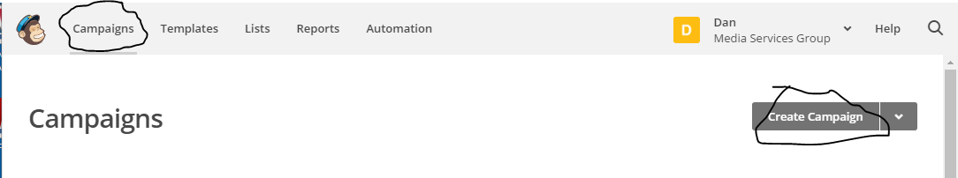

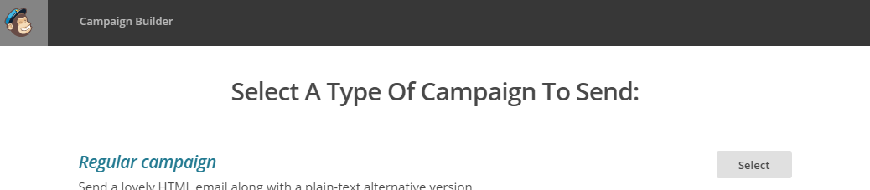

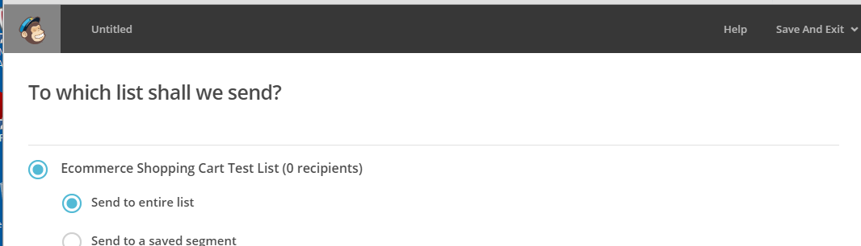
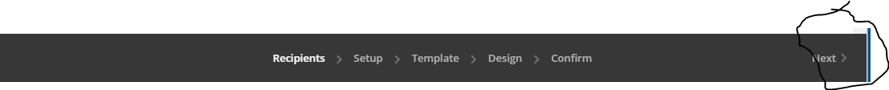

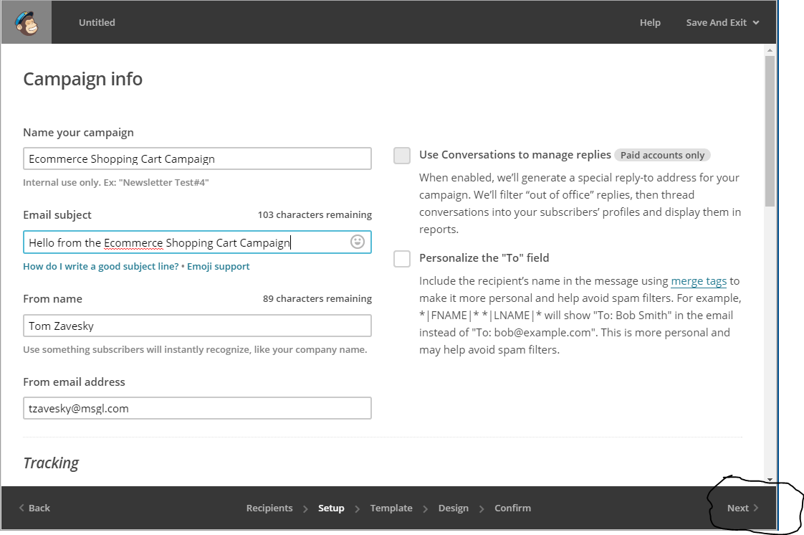

When you click NEXT here, you advance to the template designer (see below)

IMPORTANT: in the tracking section you have to check ecommerce link tracking, and OPTIONAL if you have google analytics and want mailchimp stats to go over to your analytics, check the google analytics link tracking. If you cannot check the google analytics checkbox, see below for how to get your mailchimp connected to your google analytics

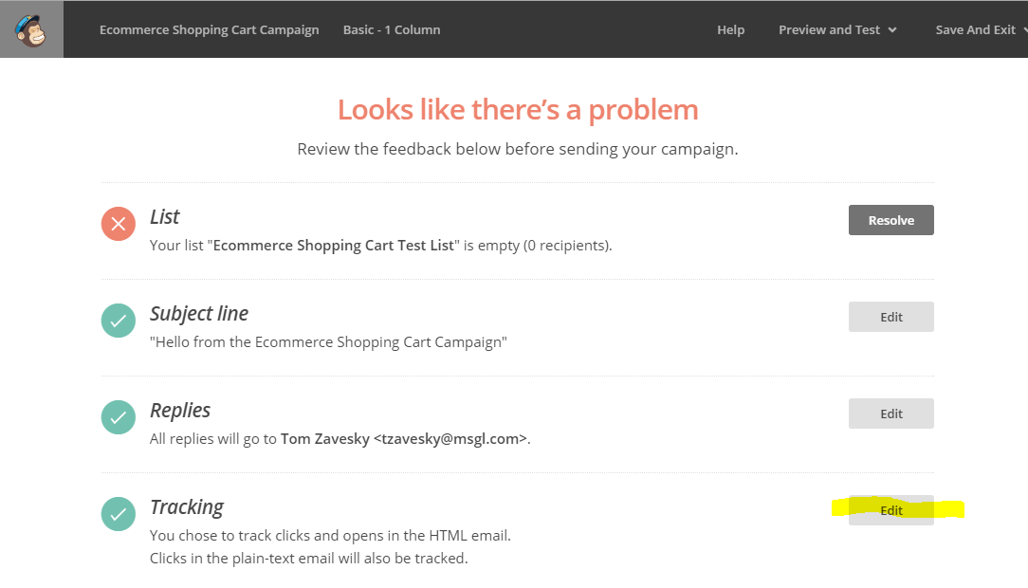
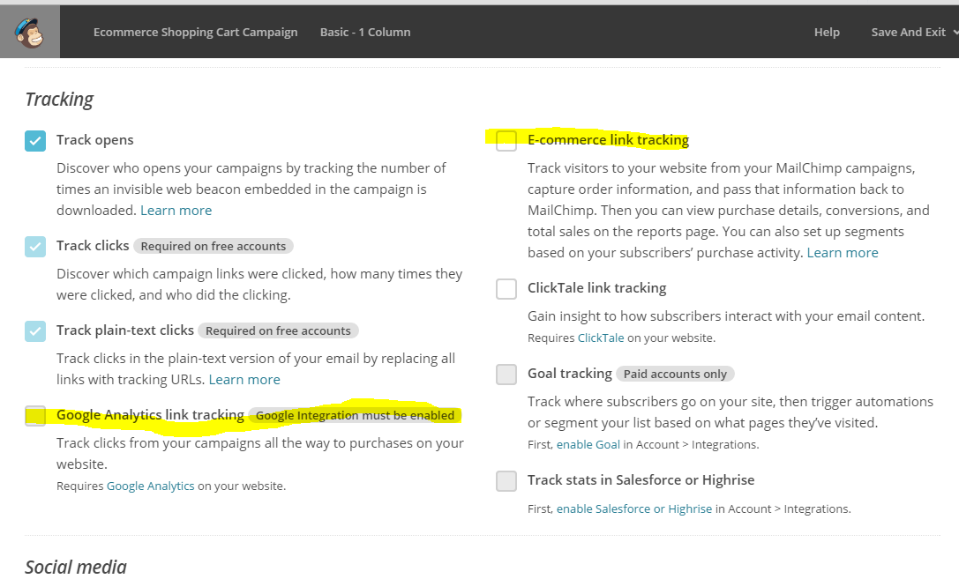

Here’s where you edit your template. This is for OUTBOUND emails. it is NOT the abandonment email! It is used by the list as an outbound template

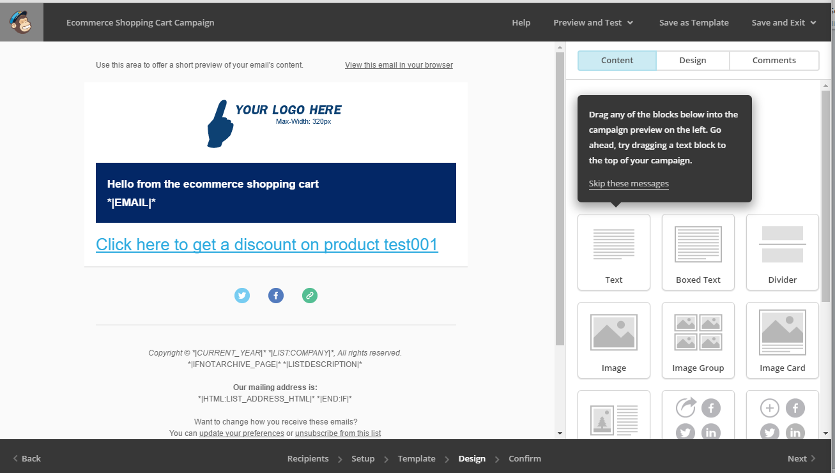

Note if you want to add an Elan campaign code, and a source code for the CMS administrator, you can create an url that looks like.

1) To send the user to the home page, and add the campaign and the source which wil track:
http://YOURSITE/Default.aspx?src=[YOURSOURCECODE]&cam=[YOURELANCAMPAIGN]
When they put an item into the cart, the source code will track (if it exists on this screen) and the campaign code will be entered into the cart for them.
Note if they have a campaign already entered it will not remove it and add this one.

Either the source code or the campaign part is optional, so if you just want to track the source use
?src=[YOURSOURCECODE]
or if you just want to add the campaign code use
?cam=[YOURCAMPAIGNCODE]

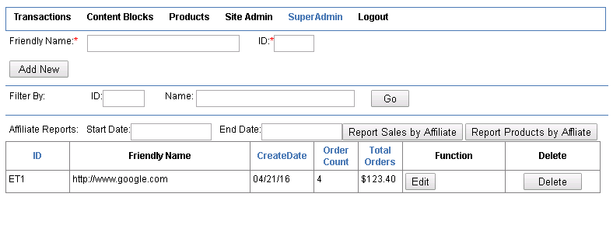

2) To add a specific product to the cart with the source and campaign

http://YOURCART/cart/Add?productId=[ElanProductId]& src=[YOURSOURCECODE]&cam=[YOURELANCAMPAIGN]

You can back to editing the template if you edit the campaign and click NEXT in the lower right in the black area.

Setting up the abandonment automation:
Note you have to have your STORE set up FIRST. So make sure you have generated your API key and delivered it to the MSG ecommerce staff so they can set it up. If you do not have it set up you wont see a “store” in the Select A Store below.

Then in mail chimp, go to Automation:
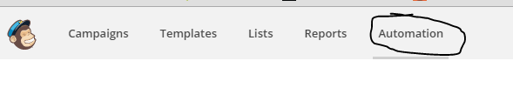
and select abandoned cart and click “add automation”
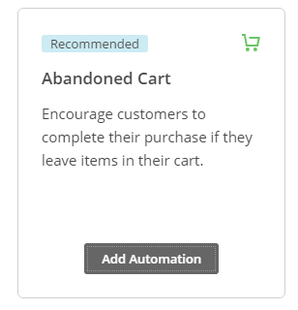
It will ask you to apply the abandonment workflow to your store.
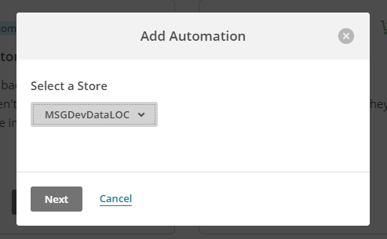

By default it sets up these options:

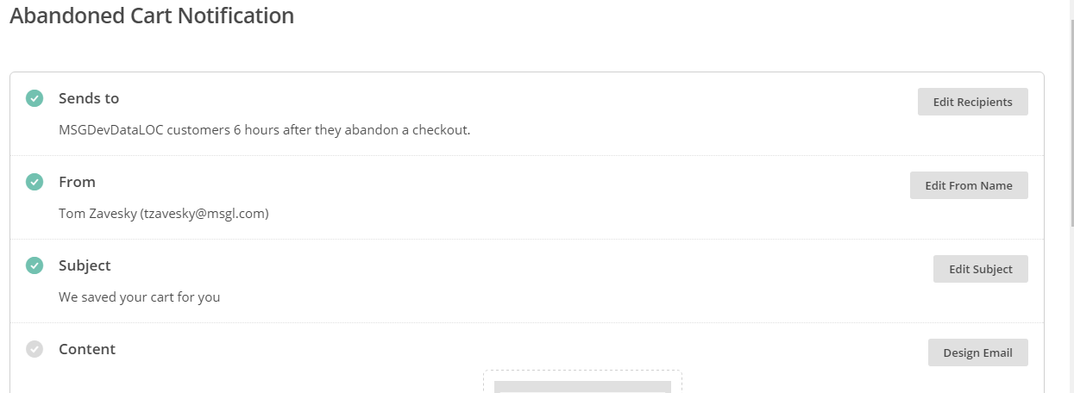

Click the design email button to select a template for your abandoned cart emails:
We’re selecting the one to the left:

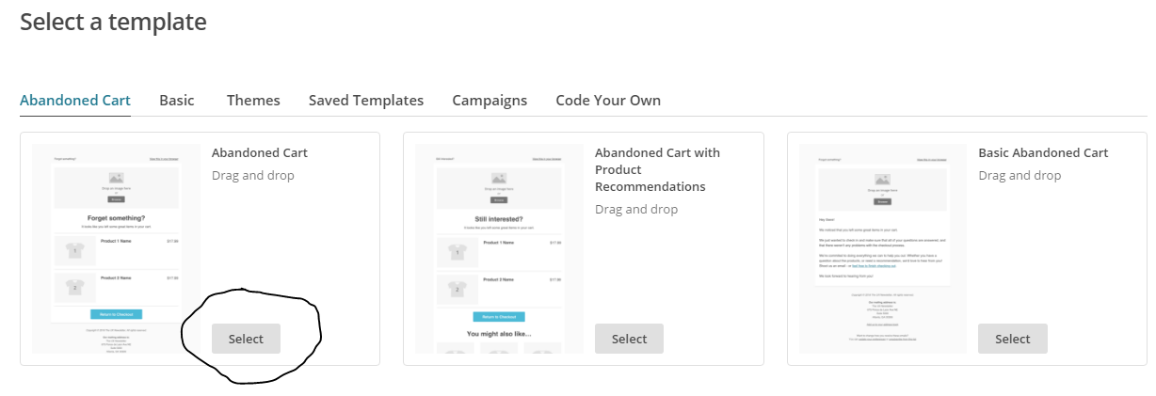

This will then take you to the editor where you can change items around

Notes:
The product list will only let you put on a maximum of three products, and allows you to toggle off the price. I don’t see a way it will let you make any other modifications.

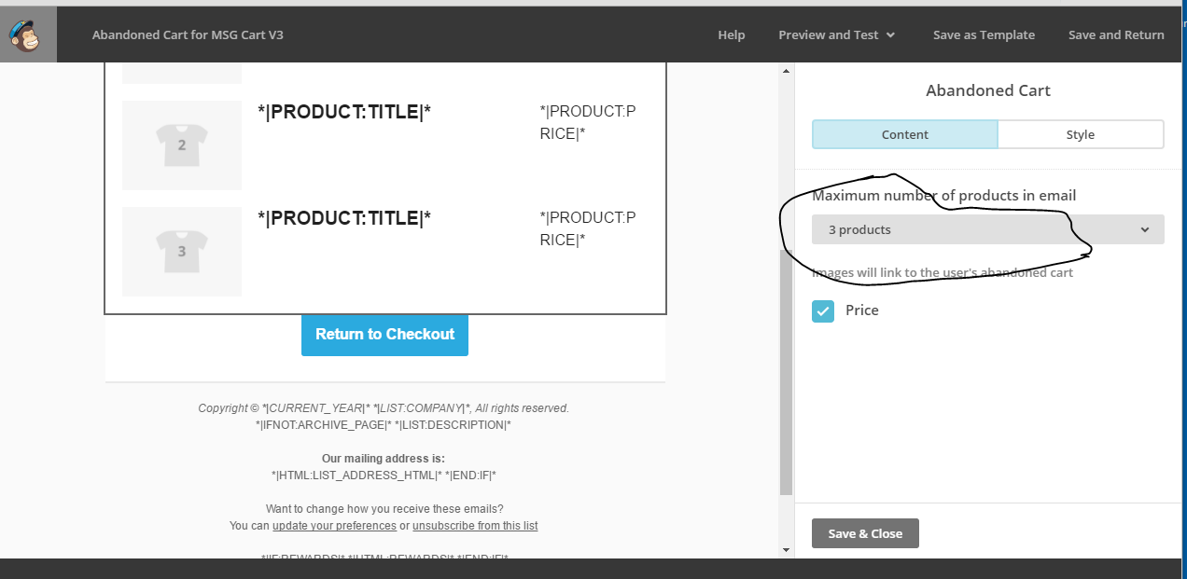

The return to checkout button just has the address of the cart.

To set up emails directly back to the cart with source and campaign codes, see above for how to set up the links in the template.

By default the RETURN TO CHECKOUT button will go back to the home page of the cart. If you want to attach a campaign, you have to change it. Click on the LinkTo and it will drop down. The default is “Abandoned cart page” which is the default page of the cart. Select “Web Address” and paste in one of the links, like to your home page, with the campaign name attached. See above for making these links:

http://YOURSITE/Default.aspx?src=[YOURSOURCECODE]&cam=[YOURELANCAMPAIGN]

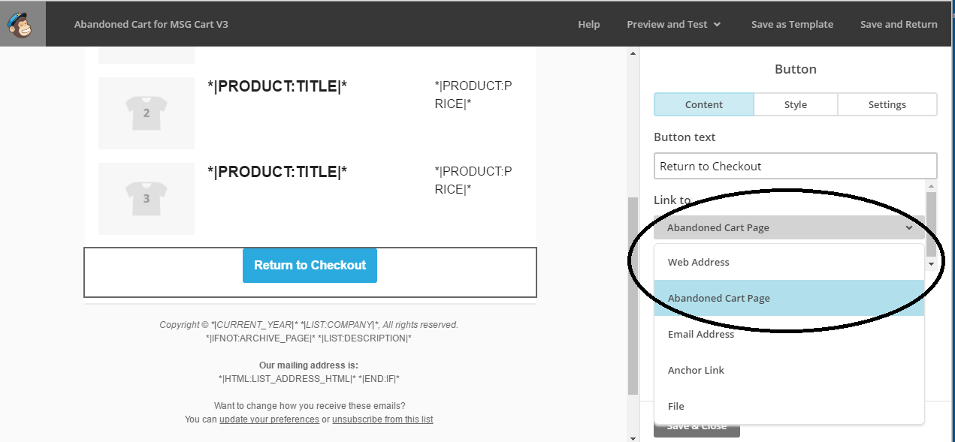

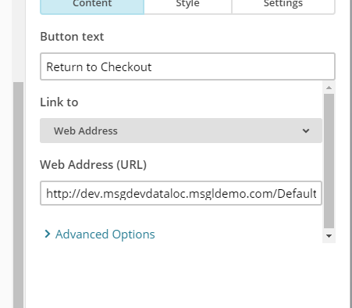

To edit the template after setup:
NOTE while your abandonment is RUNNING you cannot edit the template. You have to STOP the abandonment workflow and then you will see the edit buttons

you wil see the abandonment says paused and will allow you to edit and then resume sending:

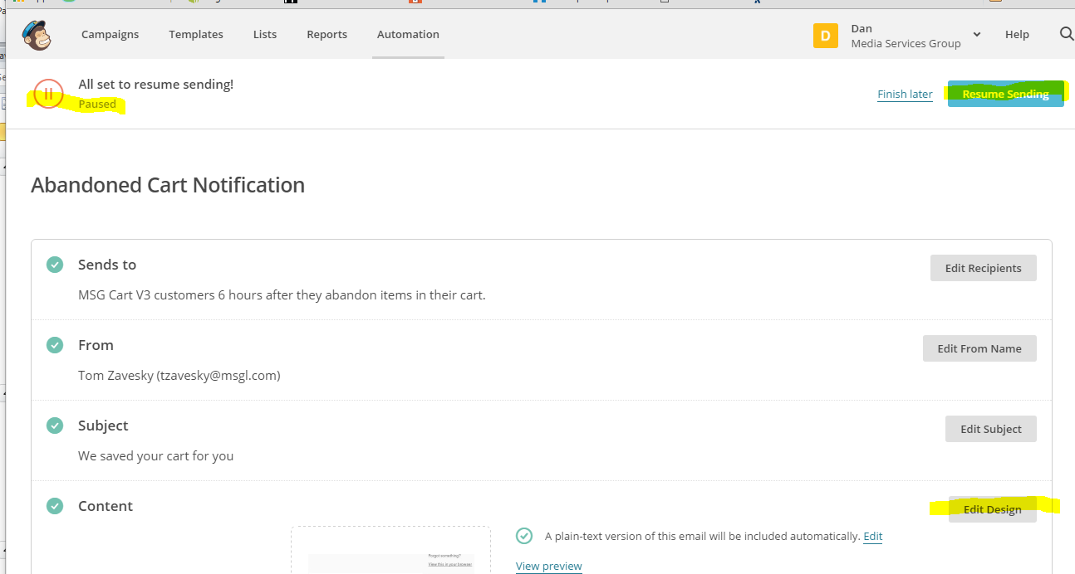

Notes:

This abandonment only allows 3 products from an abandoned cart to be listed. I don’t see any way around that.
This abandonment has two follow up times, 6 hours and 24 hours. There are no other schedules available.

Abandoned carts where a user is not logged in:

Users who are not logged in “anonymous” users will abandon the cart. In that case the, user cannot be tracked, so the abandoned individual carts will all go into the mailchimp as the default website user. The abandoment emails will go to the default email address on the website, which is usually customer service. If you need to stop those emails from sending, you have to either disable/stop that email adress in mailchimp, or dump them all into a spam folder on the recipient mailbox.

Viewing reports:

All shopping cart customers are opted in to the shopping cart list. This is the way mail chimp tracks their usage. So anyone that creates a cart will have an opted-in entry on the list. You can choose to opt them out on the list, and then the mailchimp console will not show/report statistics for them.

To view specific ecommerce reports, go to your list, then click on segmennts to add a segment

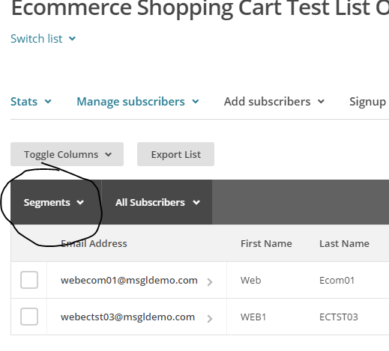

From there you can set the source dropdown to any combination of ecommerce metrics, such as Product ID.

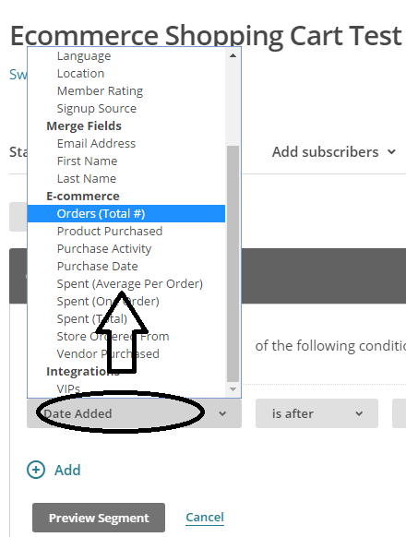

Addendum: Setting up google ecommerce conversions:

TO Set up google analytics ecommerce conversions, go to the view for the property and click on the
ecommerce settngs

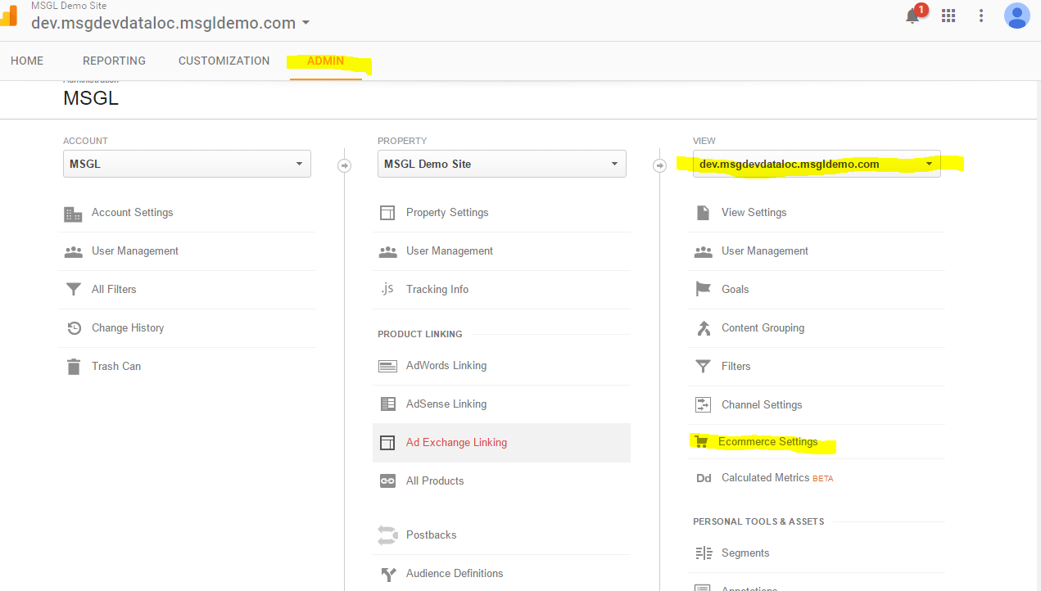

Enable the ecommerce and click submit
The code on the website does not support funnelling so you can leave this off

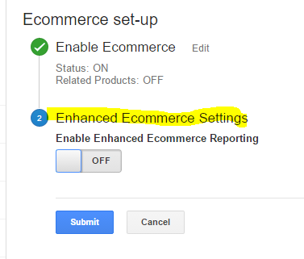

Once all that is set up you have to enable the integration in mail chimp.
Make sure you are logged in to the google account that has your google analytics data!

Go to Account -> integrations:

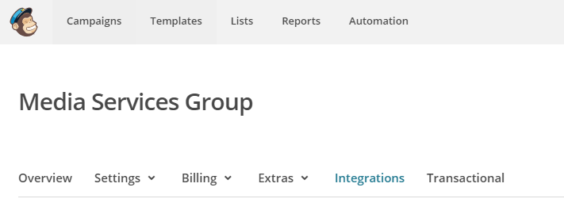
Click the account integrations -> authorize connection

It will go over to google and ask you permission to allow mailchimp to use these things:

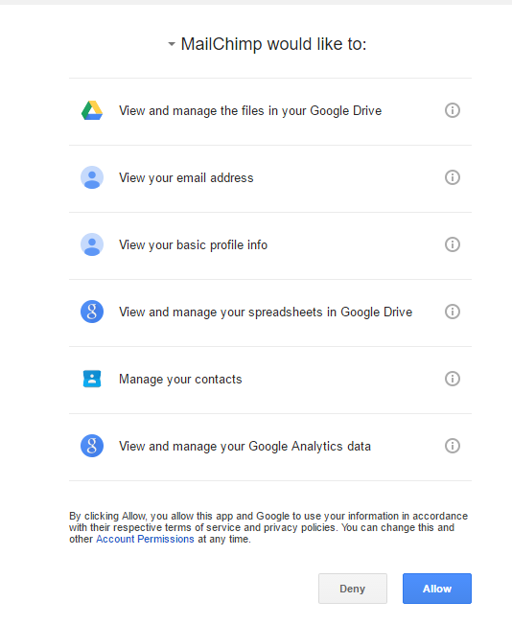
When done it will show you which account it’s connected to:

Once this is set up you can click on the GoogleAnalyticsLinkTracking in the campaign, it will show you the name of the campaign that will appear in google analytics:

